**2nd Grade Wildcat Times**

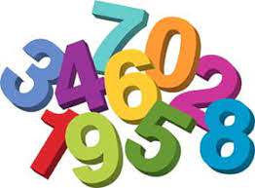**August 17-21**

Second Grade will be taking the Math Inventory this week.



**Reading- Asks and answers questions?**

*Who is the main character? Where does the story take place? What happened in the beginning, middle and end?*

**Writing- Intro to Narrative**

*What are the elements of narrative writing?*

**LA- Nouns**

*What is a common noun? What is a proper noun?*

**Math- Place Value**

*What is the place of a number? What is the value of a number?*

**Spelling (practice nightly for Friday’s test):**

**Pattern: short and long vowels**

*can his box glad pick get bus snack trade mine close came drive here safe rule replace refuse polite comment*

Reminders

* **Frozen Friday will be starting on 8-14-20 and ending on 5-21-21. If you did not prepay for the semester or year, you can still purchase ice cream. Send $1 in on each Friday with your child.**
* **Please place all money in a Ziploc bag with your child’s name on it and what it is for.**
* **Please pack a snack for your child daily. We have a working snack, so it needs to be quick and simple (eaten one-handed).**

**Please send your child into school with a sealed water bottle. The water fountains are for refilling water bottles only.**

Union's motto for success is to be respectful, be responsible, and to be safe. We love to praise kids for these positive behaviors.

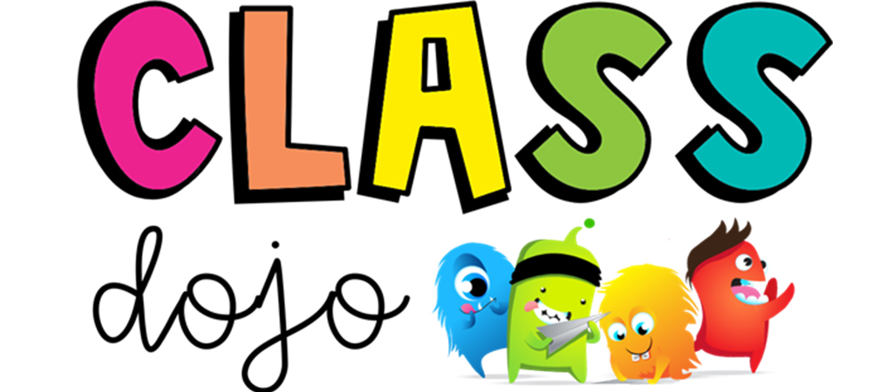

Please remember to check Class Dojo daily to see how well your child is doing.



**August 17-21 – Math Inventory administered**

**September 2 – Two-hour Early Release**

**September 7 – Labor Day No School**

**September 14-18 – Virtual Fall Spirit Sale**

**September 21-25 – Fall Break No School**

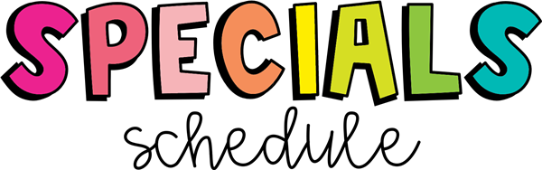

|  |  |  |  |  |  |
| --- | --- | --- | --- | --- | --- |
|  | **M** | **T** | **W** | **Th** | **F** |
| **Bowling** | STEM | M | L | PE | A |
| **Davis** | PE | L | A | M | STEM |
| **Mills** | A | PE | M | A | PE |
| **Quinn** | M | A | PE | L | M |

Please wear sneakers for PE.



Homework will begin this week. Please have your child complete it nightly and review it with your child.